CHAPTER 8: Forces, energy and motion

Worksheet 8.5

Force and gravity
Answers

Weight
1. The weight of an object is the force acting on the object in a gravitational field. The stronger the gravitational field, the greater the weight of a body. Weight is measured in the units of newtons (N)
The weight (W) of a body of mass (m) in a gravitational field (g = acceleration due to gravity) is given by the formula:
W = mg
On the Earth’s surface ‘g’ typically has a value of 9.8 m/s² but this varies with altitude and latitude. On other planets, the value of ‘g’ also changes.
Complete the table using the above formula.
Mass (kg) | Gravity (m/s²) | Weight (N)
20 | 9.8 | 20 × 9.8 = 196
30 | = 9.55 | 286.5
= 40.8 | 9.8 | 400.0

Spreadsheets and graphing
2. A spreadsheet program such as Excel is a useful computer application for tabulating data and plotting graphs. In this exercise you will practise using a spreadsheet application.
The following mass and weight data was collected from the planet Mars. The data is presented as you would set it out in the spreadsheet application.
(a) Open the spreadsheet application and enter the data as tabulated below.
(b) Select Insert from the menu bar.
(c) Select Scatter as the chart type. Select ‘Scatter with straight lines and markers’.
(d) The Design and Layout tabs can be used to insert a chart title and then each axis title and unit.
(e) Select the gridlines you would like to show.
 | A | B
1 | Mass (kg) | Weight (N)
2 | 0.0 | 0.0
3 | 0.5 | 1.9
4 | 1.0 | 3.8
5 | 1.5 | 5.7
6 | 2.0 | 7.6
7 | 2.5 | 9.5
8 | 3.0 | 11.4

CHAPTER 8: Forces, energy and motion

Worksheet 8.5

Page 2

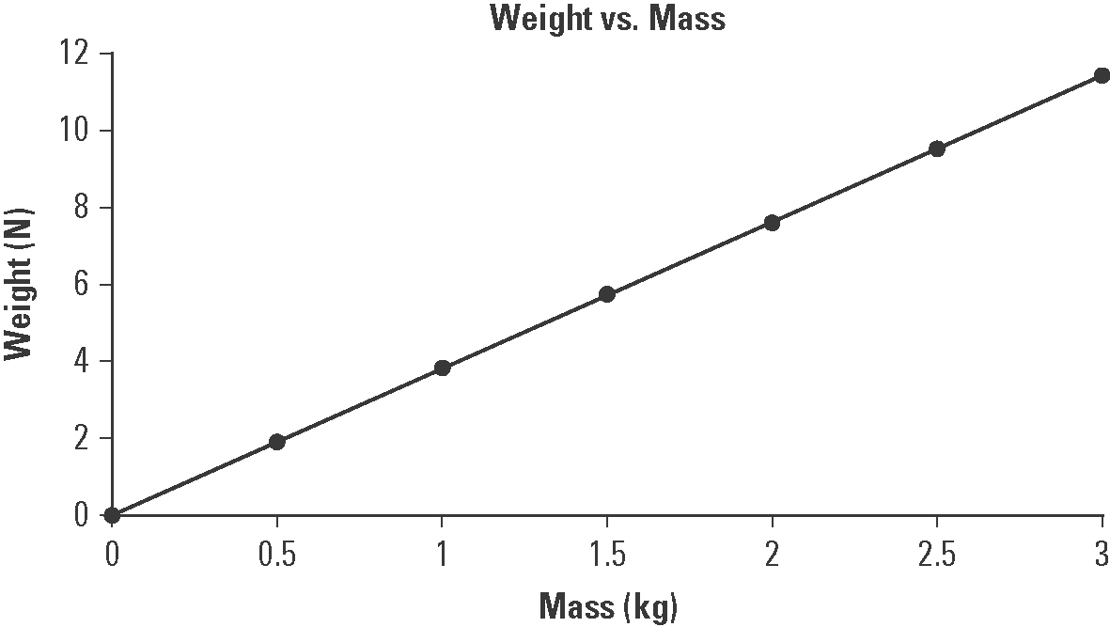

Use your chart to answer the following questions.
4.9 N
(f) Estimate the weight of a 1.3 kg body on the surface of Mars. ...................................
2.6 kg
(g) Estimate the mass of an object that weighs 10.0 N on Mars. ....................................
(h) Suggest what information the slope of the graph may provide.
W = mg can be rearranged as g = | W | .)
 | m

(Clue: The formula
The slope provides the acceleration due to gravity on the planet.

